Mathematics
The Vocabulary of Location using Etoys:
Where Am I?
Kindergarten – First Grade Levels

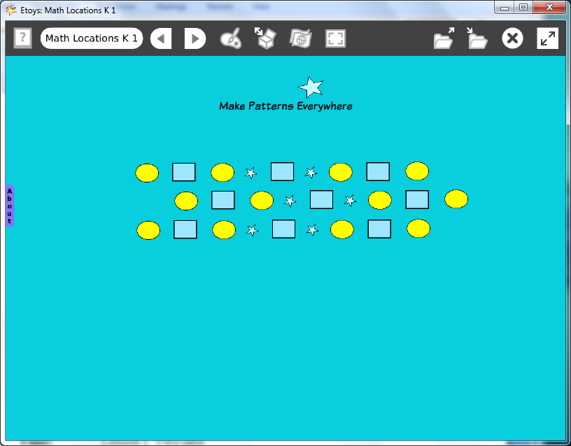

Introduction: | Students use Etoys projects to explore a vocabulary of location that is useful both on and off the computer.
Topic: | Students build a math vocabulary of position and place relationships, making connections between real shapes and locations to ones on the computer screen.
Subject: | Mathematics
Time: | Lesson 1 Two labs  Lesson 2 Two labs
Description: | In Lesson 1 Students move a star around on the computer screen following directions given by the teacher and then later by classmates.  In Lesson 2 more shapes are added and the directions become more complex. Students will sort objects by their colors or shape properties and practicing using a vocabulary of place.
Vocabulary: | above, below, top, bottom, right, left, upper, lower, center, edge, up, down, on, near, beside, before, behind, between
Evaluation Criteria: | Accurately positions the star to match the requested location.  Listens to directions by classmates.  Gives directions clearly and audibly.  Uses complete sentences when giving directions.  Knows how to open Etoys.  Knows how to open Supplies and drag out a star.
Teacher Information:  Etoys Quick Guides: Click the question mark in  Etoys to open the set of tutorials about basic tools and techniques. | Etoys Quick Guides: Click the question mark in  Etoys to open the set of tutorials about basic tools and techniques.  Use Etoys Quick Guides if the lesson mentions unfamiliar tools or techniques. Give students time to read them too.
Goals: | Students build a math vocabulary of position and place and relationships useful on the computer screen and in real spaces.
Lesson 1:  One lab | Lesson 1  Open Supplies, drag out a star, and drop it anywhere on the screen.  Explore: Ask students to use the mouse to move the star to many different places on the screen. For example:  “Position the star on the left edge”.  “Move the star to the top edge.”  “Place the star in the top left corner.”  Note: The word pattern needs time to establish itself. Do not work quickly; give students time to think and do what is asked. The purpose is to build an accurate working vocabulary.  Remind students that the tip of the cursor arrow is what does the work, not the stem.
Extend Lesson 1  Supplies: Text | Extend Lesson 1  Students give the directions. Remind students always to use a full sentence. For example: “Maria, tell us where to place the star.” Maria says, “Put the star on the left side.”  If a student gives an impossible direction such as the left/right edge, one teacher response is: “Think”, wait for a silent count of 5, then call on the same student again.  A student gives the direction and then calls on another student to give the next one. “Put the star on the left edge. Now, listen to Tracy.”  Label the screen: North, South, East, and West.  Use other shapes from the Supplies. Using two or more shapes on the screen greatly increases the complexity of the directions.  Ask students to follow direction moves within the bounds of a classroom or playground area so they can apply their new vocabulary in a familiar place.
Lesson 2:  Two or more labs | This lesson builds on Lesson 1 by asking students to think about many more objects on their screen and the relationships between them.  They will use nine shapes from Supplies to make a pattern. Ask students to drag out three rectangles, two stars and four ellipses from the Supplies.  Ask students to sort the shapes into groups on the screen.  Let students decide where to put the groups and then ask them to tell where things are. Remind them to use the vocabulary words they learned in Lesson 1.
Extend Lesson 2  Two or more labs | Ask students to make a pattern that uses all the shapes they put on the screen.  Give them time to look at other students’ screens. Are all the patterns the same?  Discuss: How are they different, are they all in the same place, do they all use the same pattern, are they all the same distances from each other?  If some students have incomplete patterns or broken ones let them use additional parts from the Supplies flap to finish their idea.  Ask students to sort ellipses into one area of the screen, stars in another area and rectangles in still another place. How many of each? How many things are there altogether?  Ask students to give directions about where to put different things on the screen. Remind them to use full sentences and speak clearly and loudly enough for their classmates to hear.
Student Information: | Students will follow and give verbal directions. An LCD projector helps the class stay together.
Standards: | Mathematics  Illinois Performance Standards  Kindergarten: Interpreting rhythmic patterns. 8A, 8B, 8D  First Grade: Exploring with manipulatives. 6B  Identify fractional parts of a region 6A  Language Arts  Illinois State Goals K-3 Listening  4.A.1a Listen attentively by facing the speaker, making eye  contact and paraphrasing what is said  4. A.1b Ask questions and respond to questions from the teacher and from group members to improve comprehension.4.A.1c Follow oral instructions accurately.  4.A.1d Use visually oriented and auditory based media  Language Arts  Illinois State Goals K-3 Speaking  4.B.1a Present brief oral reports, using language and vocabulary appropriate to the message and audience (e.g. show and tell)  4.B.1b Participate in discussions around a common topic  National Educational Technology Standards (NETS)  1. Basic operations and concepts  Students demonstrate a sound understanding of the nature and operation of technology systems.  Students are proficient in the use of technology.  3. Technology productivity tools  Students use technology tools to enhance learning, increase productivity, and promote creativity.  Students use productivity tools to collaborate in constructing technology-enhanced models, prepare publications, and produce other creative works  4. Technology communications tools  Students use telecommunications to collaborate, publish, and interact with peers, experts, and other audiences.  Students use a variety of media and formats to communicate information and ideas effectively to multiple audiences.
Resources: | Etoys Help Quick Guides: Open Etoys and click the question mark in the Navigator Bar to open a set of interactive tutorials that introduce basic tools and techniques.  EtoysIllinois.org for projects, tutorials, and lesson plans  Squeakland.org Etoys software
kh
April 9, 2012

